
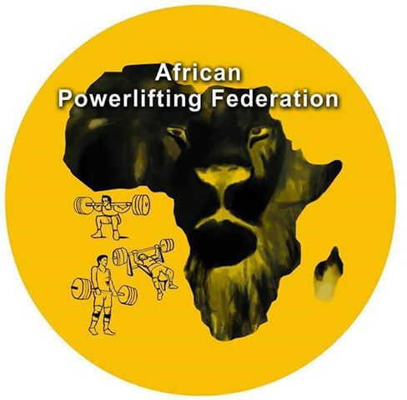
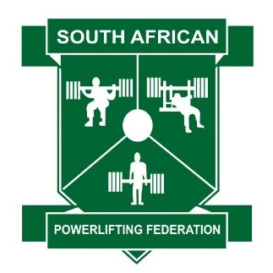

OFFICIAL INVITATION

The African Powerlifting Federation and the South Africa Powerlifting Federation Invite’s the APF member nations to participate in the
AFRICAN POWERLIFTING CHAMPIONSHIPS
Masters, Sub-Junior, Junior & Open categories
Tuesday 1st October – Saturday 5th October 2019
In Potchefstroom South Africa

Please note: all information is posted only for information purposes. All team selections, all official entries for the Championships and all hotel bookings must be done by APF-Member nations, NOT by individuals.

Meet Director: Johan (Hannie) Smith hannie@lagayim.co.za
Cell: +27 82 5663433 Fax +27 86 5243879

Correspondence & Visa support: Johan (Hannie) Smith & Vicki Botha hannie@lagayim.co.za

Nominations: Heather Leighton heatherjleighton@gmail.com
Meet Director Hannie Smith email: hannie@lagayim.co.za

Championship Secretary : Johan Smith hannie@lagayim.co.za
Cell: +27 82 5663433 Fax +27 86 5243879

Accommodation: Helen De Wet williwsgch@mweb.co.za +27 18 297 5411 Fax +27 86 646 3689

Transport: Johan (Hannie) Smith hannie@lagayim.co.za
Cell: +27 82 5663433 Fax +27 86 5243879

Technical Secretary: Vicki Botha email : hannie@lagayim.co.za

Host City: Potchefstroom South Africa
Date: Tuesday 1st – 5th October 2019
Venue: Elgro Convention Centre Wolmarans street Potchefstroom South Africa
Examinations : If anyone wish to write the examination they need to apply online on the IPF webpage. Patrik Thur must first approved such an examination
Congress : Tuesday 1st October 2019, 16:00 hrs at the – Drostdy Venue 1st Floor – Elgro Hotel
Technical Meeting: Tuesday 1st October 2019, 19:00 at Elgro Hotel Potchefstroom

Hotel: - Elgro Hotel & Williws Hotel Helen De Wet williwsgch@mweb.co.za +27 18 297 5411 Fax +27 86 646 3689
Option 1 Luxury Accommodation
Single Room R1 350.00 per person per night Bed, and Breakfast (Double Bed)
Double / Twin Room R1 750.00 per room per night Bed and Breakfast (2 Beds)

Option 2 Standard Accommodation
Single Room R1050.00 per person per night Bed, and Breakfast (Bouble Bed)
Double / Twin Room R1 485.00 per room per night Bed and Breakfast (2 Beds)

Dinner can be booked at reception at The ELGRO Hotel at the rate of R250.00 per person per night.

Here are some of the facilities we are able to offer our guests in our rooms:
Tea/Coffee Making facilities
Air Conditioning
On-Suite Bathrooms
Accommodation fees payable by Credit/Debit card;
1. Cash in RAND, EUR and DOLLAR (according to the current exchange rate);
2. Bank transfer to the following bank account:
Banking details:
Account name: ELGRO HOTEL
Account: Absa Bank
Account number: 680 146 934
Branch: POTCHEFSTROOM
Branch code: 632005
Swift code: ABSAZAJJ
I-Ban Code: ZA632005

Note 1: All athletes, coaches, referees and officials from each federation have to book their rooms with Helen de Wet – ELGRO HOTEL and have to stay in the official hotel during the championship. If athletes, coaches, referees or officials do not stay in the official hotel during the entire time in attendance at the championship, they will be obliged to pay an administration fee of 100 EUR per person to the organizer. Failure to comply will have the effect that they will not receive accreditation and will be excluded from that championship (By-Laws 105.4.4)

Note 2: The organizer will not be responsible for any Extra hotel bills of the participating nations. All delegates must pay directly their rooms to the Elgro Hotel.

Payment must be received at the above mentioned bank account at the latest 7 days prior to the beginning of the Championship. All bank charges go at the expense of order party. If you choose the payment by bank transfer or by credit card, you must inform the organizer in advance. All rooms must be booked at the latest with the deadline of the final nomination – 11th September 2019 is the latest date for any removal of nominated lifters, cancellation of booked hotel rooms or change in the number of ordered banquet tickets. If not cancelled in time, federations have to pay the reserved hotel rooms, the participation fee, the doping and the banquet tickets for all lifters and officials specified at the final nomination form.

Arrivals/Transportation:
Transport from OR-TAMBO International Airport to ELGRO Hotel is Euro 55 one way. Euro 110 Both way’s & includes the shuttle service between the Venue and all Hotels. Payment will be in Cash/Card on arrival to the Meet Director.
Please send your detailed travel itinerary to the Meet Director Hannie Smith - email: hannie@lagayim.co.za and Vicki Botha email; hannie@lagayim.co.za so that the transfer can be provided

Scales: Scales available at the official hotels.
Training: Training facilities available in Warm-up area at the venue.
Opening Ceremony: Wednesday 2nd October,14:00 at the Venue. All representatives from each participating country shall take part at the Ceremony.

Closing Banquet: Saturday 5th October 2019, 20:00
Price per ticket for one person: 35,00 EUR paid on arrival to the Meet Director
Soft Drings on tables free.
The number of banquet tickets must be ordered at the Nomination form.

Participation Fee: 40,00 EUR for each lifter must be paid by to the APF
at the Technical Meeting. APF invoice will be sent by the APF Treasurer 7 days
before the Technical Meeting.
Anti-Doping Fee: 60,00 EUR for each lifter must be paid by bank transfer to the IPF bank account OR CASH at Technical Meeting
before the Technical Meeting. IPF invoice will be sent by the IPF Treasurer 7 days before the Technical Meeting.

Flag and anthem: Flags & Anthems will be provided by organizers.
Health and travel
Insurance: All delgate must have a valid health insurance. The organiser and the APF will not incur any expenses for a doctor or hospital. We recommed travel insurance for covering loss of luggage, theft, delayed planes, ect.

Nominations : Team nomination forms must be in the hands of the Meet Director
hannie@lagayim.co.za and Heather Leighton heatherjleighton@gmail.com the APF President Moussa Messaour federationfabbfpl2006@hotmail.com

Preliminary : 3th August (complete filled in preliminary form must be sent. No final nomination will be accepted if complete filled in the preliminary was not sent).
Final : 11th September (later entries will not be accepted).
Correspondence : Emails regarding the championships must be sent to Johan Smith,
hannie@lagayim.co.za

Provisional Timetable of Events
Africa Powerlifting & Bench Press Championships
in Potchefstroom, South Africa
Provisional timetable
Day | Weigh in time | Classes | Start
Tuesday 1st October |  | Technical meeting | 19:00
Wednesday 2nd October | 08:00 - 09:30 | Bench Press – Raw Women All | 10:00
 |  | OPENING CEREMOMY | 13:00
 | 12:00 - 13:30 | Bench Press – Raw Men All | 14:00
 | 15:00 – 16:30 | Bench Press – Equipped Men & Women | 17:00
Thursday 3rd October | 07:00 - 08:30 | Equipped Powerlifting – Men & Women | 09:00
 | 11:00 - 12:30 | Raw Men 53 kg – 66 kg | 13:00
 | 15:00 – 16:30 | Raw Women 43 kg – 57 kg | 17:00
Friday 4th October | 07:00 – 08:30 | Raw Men 74 kg – 83 kg | 09:00
 | 11:00 – 12:30 | Raw Women 63 kg – 72 kg  en M3 93 kg – 120 + kg | 13:00
 | 15:00 – 16:30 | Raw Men 93 kg – 105 kg | 17:00
Saturday 5th October | 07:00 – 08:30 | Raw Women 84 kg - +84 kg | 09:00
 | 11:00 – 12:30 | Raw Men 120kg - +120 kg | 13:00
 |  | BANQUET | 19:00

Important Items to Remember

Preliminary nomination forms must be sent not later than 60 days before the date of the Championship. Final nominations must be submitted no later than 21 days before the date of the Championship and must include only names from the preliminary nomination (i.e. only lifters from the preliminary nomination can be replaced by a nominated reserve lifter. No new nominations will be accepted).

According Technical Rules [Page 4, item 7] on the submitted Final Nomination Form you must send the finalized list the athletes that will take part in the championship. At the Technical Meeting you can only delete athletes from your final nomination form and no one can change weight classes.

Changes may occur to the timetable of events. All changes will take place at the technical meeting that will be held on Tuesday, 1st October 2018 at 19:00 in the Drostdy Venue 1st Floor – Elgro Hotel.

Victory Ceremonies will be held at the end of each lifting session. It will be absolutely mandatory that each athlete wear their National Team Warm-up/Track Suit for the award presentation.

If the organizer does not receive confirmed cancellations of hotel rooms at least 21 days prior to the championship, all hotel costs will be the responsibility of nominated lifters and officials. The same shall apply to participation and Anti-Doping fees (IPF-By-Laws105.5.2).

All athletes, coaches, referees or officials from each federation must stay in the official hotel during the course of the championship. From the time of their arrival to their departure. If athletes, coaches, referees or officials do not stay in the official hotel during the championship, they will be obligated to pay an administration fee of € 100 per person to the organizer. Failure to comply with this rule, will not receive accreditation and will be excluded from that championship (IPF By-laws 105.4.4).

Johan Smith - Meet Director

